**USER_TABLE**

CREATE TABLE USER_TABLE

(

username VARCHAR2(50) NOT NULL PRIMARY KEY,

email_address VARCHAR2(100),

DOB DATE,

ppassword VARCHAR2(20) NOT NULL,

ddescription VARCHAR2(255)

);

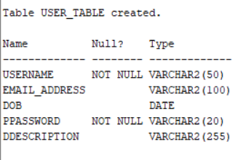

**USER_PHN_NO_TABLE**

CREATE TABLE USER_PHN_NO_TABLE

(

username VARCHAR2(50) NOT NULL,

phone_no VARCHAR2(100) NOT NULL,

PRIMARY KEY(username, phone_no),

CONSTRAINT FK_USER_PHN_NOusername FOREIGN KEY

(username) REFERENCES USER_TABLE (username) ON DELETE CASCADE

);

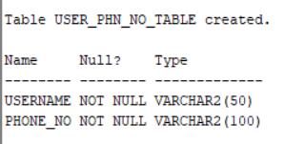

**CUSTOMER_TABLE**

CREATE TABLE CUSTOMER_TABLE

(

username VARCHAR2(50) NOT NULL PRIMARY KEY,

street VARCHAR2(100) NOT NULL,

city VARCHAR2(100) NOT NULL,

sstate VARCHAR2(100) NOT NULL,

first_name VARCHAR2(50),

last_name VARCHAR2(50),

CONSTRAINT FK_CUSTOMERusername FOREIGN KEY

(username) REFERENCES USER_TABLE (username) ON DELETE CASCADE

);

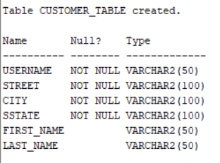

**ADMINISTRATOR_TABLE**

CREATE TABLE ADMINISTRATOR_TABLE

(

username VARCHAR2(50) NOT NULL PRIMARY KEY,

CONSTRAINT FK_ADMINISTRATORusername FOREIGN KEY

(username) REFERENCES USER_TABLE (username) ON DELETE CASCADE

);

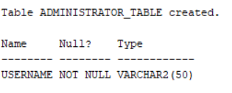

**ORDERS_TABLE**

CREATE TABLE ORDERS_TABLE

(

order_id NUMBER(10, 0) NOT NULL PRIMARY KEY,

invoice_no NUMBER(10, 0) NOT NULL UNIQUE,

order_date TIMESTAMP DEFAULT CURRENT_DATE NOT NULL,

order_status VARCHAR2(100) NOT NULL,

username VARCHAR2(50) NOT NULL,

CONSTRAINT FK_ORDERSusername FOREIGN KEY

(username) REFERENCES CUSTOMER_TABLE (username) ON DELETE CASCADE

);

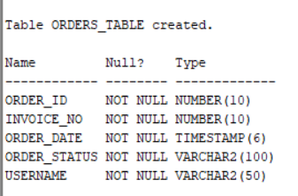

**TRACKING_DETAILS_TABLE**

CREATE TABLE TRACKING_DETAILS_TABLE

(

tracking_id NUMBER(10, 0) NOT NULL,

order_id NUMBER(10, 0) NOT NULL,

courier_name VARCHAR2(100) NOT NULL,

update_time TIMESTAMP DEFAULT CURRENT_DATE NOT NULL,

ddescription VARCHAR2(100) NOT NULL,

PRIMARY KEY(tracking_id, order_id),

CONSTRAINT FK_TRACKING_DETAILSorder_id FOREIGN KEY

(order_id) REFERENCES ORDERS_TABLE (order_id) ON DELETE CASCADE

);

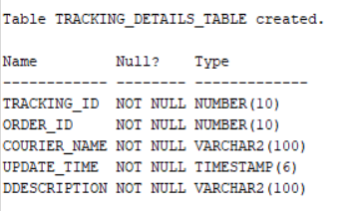

**ORDER_DETAILS_TABLE**

CREATE TABLE ORDER_DETAILS_TABLE

(

order_details_id NUMBER(10, 0) NOT NULL UNIQUE,

order_id NUMBER(10, 0) NOT NULL,

discount DECIMAL(5, 2) DEFAULT 0 CHECK (discount >= 0 AND discount <= 100) NOT NULL,

amount_to_pay NUMBER(10, 3) DEFAULT 0 NOT NULL,

PRIMARY KEY(order_details_id, order_id),

CONSTRAINT FK_ORDER_DETAILS_TABLEorder_id FOREIGN KEY

(order_id) REFERENCES ORDERS_TABLE (order_id) ON DELETE CASCADE

);

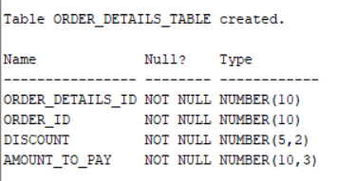

**AUTHOR_TABLE**

CREATE TABLE AUTHOR_TABLE

(

author_id NUMBER(10, 0) NOT NULL PRIMARY KEY,

author_name VARCHAR2(50) NOT NULL,

email_address VARCHAR2(100) NOT NULL

);

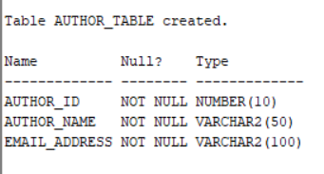

**PUBLISHER_TABLE**

CREATE TABLE PUBLISHER_TABLE

(

publisher_id NUMBER(10, 0) NOT NULL PRIMARY KEY,

publisher_name VARCHAR2(100) NOT NULL,

email_address VARCHAR2(100) NOT NULL,

website VARCHAR2(100) NOT NULL

);

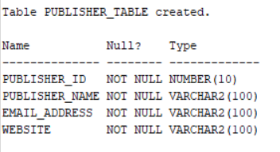

**BOOK_TABLE**

CREATE TABLE BOOK_TABLE

(

book_ISBN NUMBER(10, 0) NOT NULL PRIMARY KEY,

book_title VARCHAR2(255),

eedition NUMBER(2, 0),

price NUMBER(7, 3) NOT NULL,

EOQ NUMBER(7, 3),

author_id NUMBER(10, 0) NOT NULL,

publisher_id NUMBER(10, 0) NOT NULL,

release_date DATE,

page_count NUMBER(4, 0),

dimensions VARCHAR2(50),

quantity_in_stock NUMBER(6, 0) DEFAULT 0 CHECK (quantity_in_stock >= 0) NOT NULL,

CONSTRAINT FK_BOOKauthor_id FOREIGN KEY

(author_id) REFERENCES AUTHOR_TABLE (author_id) ON DELETE CASCADE,

CONSTRAINT FK_BOOKpublisher_id FOREIGN KEY

(publisher_id) REFERENCES PUBLISHER_TABLE (publisher_id) ON DELETE CASCADE

);

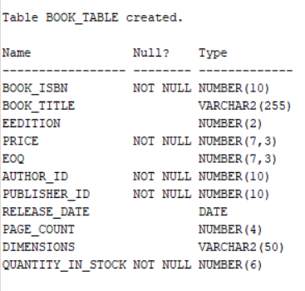

**BOOK_INSTANCE_TABLE**

CREATE TABLE BOOK_INSTANCE_TABLE

(

copy_instance NUMBER(10, 0) NOT NULL,

book_ISBN NUMBER(10, 0) NOT NULL,

quantity NUMBER(5, 0) NOT NULL,

order_details_id NUMBER(10, 0) NOT NULL,

order_id NUMBER(10, 0) NOT NULL,

PRIMARY KEY(copy_instance, book_ISBN),

CONSTRAINT FK_BOOK_INSTANCEbook_ISBN FOREIGN KEY

(book_ISBN) REFERENCES BOOK_TABLE (book_ISBN) ON DELETE CASCADE,

CONSTRAINT FK_BOOK_INSTANCEorder_details_id FOREIGN KEY

(order_details_id) REFERENCES ORDER_DETAILS_TABLE (order_details_id) ON DELETE CASCADE,

CONSTRAINT FK_BOOK_INSTANCEorder_id FOREIGN KEY

(order_id) REFERENCES ORDERS_TABLE (order_id) ON DELETE CASCADE

);

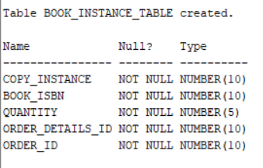

**CATEGORY_TABLE**

CREATE TABLE CATEGORY_TABLE

(

category_id NUMBER(10, 0) NOT NULL PRIMARY KEY,

category_name VARCHAR2(50) NOT NULL,

parent_id NUMBER(10, 0),

CONSTRAINT FK_CATEGORYparent_id FOREIGN KEY

(parent_id) REFERENCES CATEGORY_TABLE (category_id) ON DELETE SET NULL

);

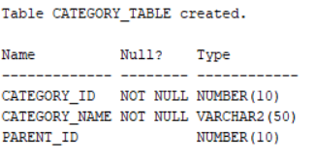

**LANGUAGE_TABLE**

CREATE TABLE LANGUAGE_TABLE

(

language_id NUMBER(10, 0) NOT NULL PRIMARY KEY,

language_name VARCHAR2(50) NOT NULL,

ddescription VARCHAR2(255)

);

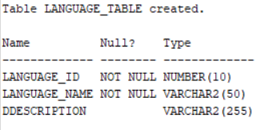

**BINDING_TABLE**

CREATE TABLE BINDING_TABLE

(

binding_id NUMBER(10, 0) NOT NULL PRIMARY KEY,

binding_type VARCHAR2(50) NOT NULL,

ddescription VARCHAR2(255)

);

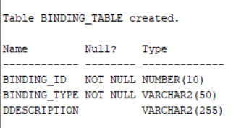

**BOOK_CATEGORY_TABLE**

CREATE TABLE BOOK_CATEGORY_TABLE

(

category_id NUMBER(10, 0) NOT NULL,

book_ISBN NUMBER(10, 0) NOT NULL,

PRIMARY KEY(category_id, book_ISBN),

CONSTRAINT FK_BOOK_CATEGORY_TABLEcategory_id FOREIGN KEY

(category_id) REFERENCES CATEGORY_TABLE (category_id) ON DELETE CASCADE,

CONSTRAINT FK_BOOK_CATEGORY_TABLEbook_ISBN FOREIGN KEY

(book_ISBN) REFERENCES BOOK_TABLE (book_ISBN) ON DELETE CASCADE

);

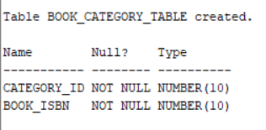

**BOOK_LANGUAGE_TABLE**

CREATE TABLE BOOK_LANGUAGE_TABLE

(

language_id NUMBER(10, 0) NOT NULL,

book_ISBN NUMBER(10, 0) NOT NULL,

PRIMARY KEY(language_id, book_ISBN),

CONSTRAINT FK_BOOK_LANGUAGE_TABLElanguage_id FOREIGN KEY

(language_id) REFERENCES LANGUAGE_TABLE (language_id) ON DELETE CASCADE,

CONSTRAINT FK_BOOK_LANGUAGE_TABLEbook_ISBN FOREIGN KEY

(book_ISBN) REFERENCES BOOK_TABLE (book_ISBN) ON DELETE CASCADE

);

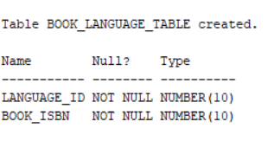

**BOOK_BINDING_TABLE**

CREATE TABLE BOOK_BINDING_TABLE

(

binding_id NUMBER(10, 0) NOT NULL,

book_ISBN NUMBER(10, 0) NOT NULL,

PRIMARY KEY(binding_id, book_ISBN),

CONSTRAINT FK_BOOK_BINDING_TABLEbinding_id FOREIGN KEY

(binding_id) REFERENCES BINDING_TABLE (binding_id) ON DELETE CASCADE,

CONSTRAINT FK_BOOK_BINDING_TABLEbook_ISBN FOREIGN KEY

(book_ISBN) REFERENCES BOOK_TABLE (book_ISBN) ON DELETE CASCADE

);

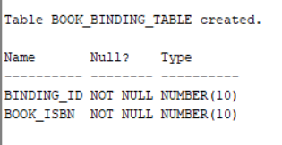

**SUPPLIER_TABLE**

CREATE TABLE SUPPLIER_TABLE

(

supplier_id NUMBER(10, 0) NOT NULL PRIMARY KEY,

email_address VARCHAR2(100) NOT NULL,

supplier_name VARCHAR2(100) NOT NULL,

contact_no VARCHAR2(100) NOT NULL,

street VARCHAR2(100) NOT NULL,

city VARCHAR2(100) NOT NULL,

sstate VARCHAR2(100) NOT NULL

);

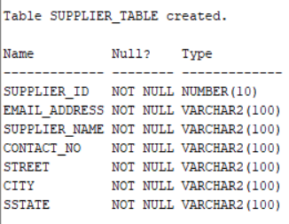

**SUPPLIES_TO_TABLE**

CREATE TABLE SUPPLIES_TO_TABLE

(

publisher_id NUMBER(10, 0) NOT NULL,

supplier_id NUMBER(10, 0) NOT NULL,

book_ISBN NUMBER(10, 0) NOT NULL UNIQUE,

amount NUMBER(6, 0) NOT NULL CHECK (amount >= 0),

PRIMARY KEY(publisher_id, supplier_id),

CONSTRAINT FK_SUPPLIES_TO_TABLEpublisher_id FOREIGN KEY

(publisher_id) REFERENCES PUBLISHER_TABLE (publisher_id) ON DELETE CASCADE,

CONSTRAINT FK_SUPPLIES_TO_TABLEsupplier_id FOREIGN KEY

(supplier_id) REFERENCES SUPPLIER_TABLE (supplier_id) ON DELETE CASCADE

);

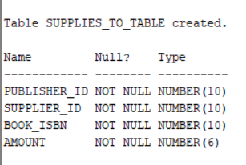

**WAREHOUSE_TABLE**

CREATE TABLE WAREHOUSE_TABLE

(

warehouse_id NUMBER(10, 0) NOT NULL PRIMARY KEY,

warehouse_name VARCHAR2(100) NOT NULL,

street VARCHAR2(100) NOT NULL,

city VARCHAR2(100) NOT NULL,

sstate VARCHAR2(100) NOT NULL,

manager_contact VARCHAR2(100) NOT NULL

);

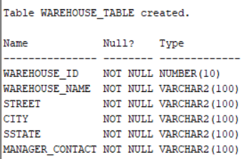

**PROVIDES_BOOKS_TABLE**

CREATE TABLE PROVIDES_BOOKS_TABLE

(

supplier_id NUMBER(10, 0) NOT NULL,

warehouse_id NUMBER(10, 0) NOT NULL,

book_ISBN NUMBER(10, 0) NOT NULL UNIQUE,

amount NUMBER(6, 0) NOT NULL CHECK (amount >= 0),

PRIMARY KEY(supplier_id, warehouse_id),

CONSTRAINT FK_PROVIDES_BOOKS_TABLEsupplier_id FOREIGN KEY

(supplier_id) REFERENCES SUPPLIER_TABLE (supplier_id) ON DELETE CASCADE,

CONSTRAINT FK_PROVIDES_BOOKS_TABLEwarehouse_id FOREIGN KEY

(warehouse_id) REFERENCES WAREHOUSE_TABLE (warehouse_id) ON DELETE CASCADE

);

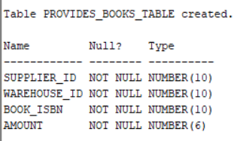

**BOOKS_WITH_SUPPLIERS_TABLE**

CREATE TABLE BOOKS_WITH_SUPPLIERS_TABLE

(

track_id NUMBER(10, 0) NOT NULL PRIMARY KEY,

book_ISBN NUMBER(10, 0) NOT NULL UNIQUE,

quantity NUMBER(6, 0) DEFAULT 0 CHECK (quantity >= 0) NOT NULL

);

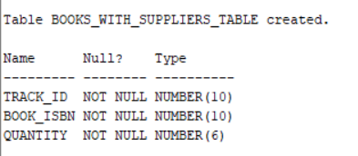

**HAVE_BOOKS_TABLE**

CREATE TABLE HAVE_BOOKS_TABLE

(

supplier_id NUMBER(10, 0) NOT NULL,

track_id NUMBER(10, 0) NOT NULL,

PRIMARY KEY(supplier_id, track_id),

CONSTRAINT FK_HAVE_BOOKS_TABLEsupplier_id FOREIGN KEY

(supplier_id) REFERENCES SUPPLIER_TABLE (supplier_id) ON DELETE CASCADE,

CONSTRAINT FK_HAVE_BOOKS_TABLEtrack_id FOREIGN KEY

(track_id) REFERENCES BOOKS_WITH_SUPPLIERS_TABLE (track_id) ON DELETE CASCADE

);

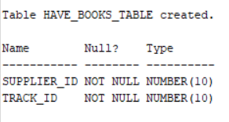

**BOOKS_IN_WAREHOUSE_TABLE**

CREATE TABLE BOOKS_IN_WAREHOUSE_TABLE

(

track_id NUMBER(10, 0) NOT NULL PRIMARY KEY,

book_ISBN NUMBER(10, 0) NOT NULL,

quantity NUMBER(6, 0) DEFAULT 0 CHECK (quantity >= 0) NOT NULL

);

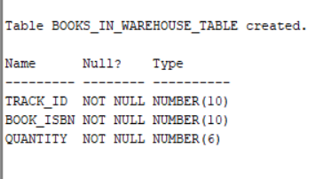

**CONTAINS_BOOKS_TABLE**

CREATE TABLE CONTAINS_BOOKS_TABLE

(

warehouse_id NUMBER(10, 0) NOT NULL,

track_id NUMBER(10, 0) NOT NULL,

PRIMARY KEY(warehouse_id, track_id),

CONSTRAINT FK_CONTAINS_BOOKS_TABLEwarehouse_id FOREIGN KEY

(warehouse_id) REFERENCES WAREHOUSE_TABLE (warehouse_id) ON DELETE CASCADE,

CONSTRAINT FK_CONTAINS_BOOKS_TABLEbook_ISBN FOREIGN KEY

(track_id) REFERENCES BOOKS_IN_WAREHOUSE_TABLE (track_id) ON DELETE CASCADE

);

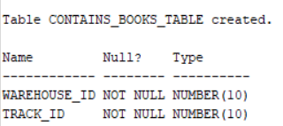

**USER_INTERACTION_TABLE**

CREATE TABLE USER_INTERACTION_TABLE

(

username VARCHAR2(50) NOT NULL,

book_ISBN NUMBER(10, 0) NOT NULL,

rating NUMBER(1, 0),

upvote CHAR(1),

downvote CHAR(1),

PRIMARY KEY(username, book_ISBN),

CONSTRAINT FK_USER_INTERACTION_TABLEusername FOREIGN KEY

(username) REFERENCES CUSTOMER_TABLE (username) ON DELETE CASCADE,

CONSTRAINT FK_USER_INTERACTION_TABLEbook_ISBN FOREIGN KEY

(book_ISBN) REFERENCES BOOK_TABLE (book_ISBN) ON DELETE CASCADE

);

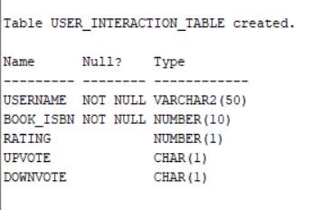

**FAVOURITES_TABLE**

CREATE TABLE FAVOURITES_TABLE

(

favourite_id NUMBER(10, 0) NOT NULL PRIMARY KEY,

reason VARCHAR2(255)

);

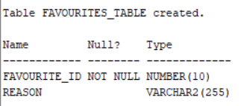

**USER_FAVOURITE_TABLE**

CREATE TABLE USER_FAVOURITE_TABLE

(

username VARCHAR2(50) NOT NULL,

book_ISBN NUMBER(10, 0) NOT NULL,

favourite_id NUMBER(10, 0) NOT NULL,

PRIMARY KEY(username, book_ISBN, favourite_id),

CONSTRAINT FK_USER_FAVOURITE_TABLEusernamebook_ISBN FOREIGN KEY

(username, book_ISBN) REFERENCES USER_INTERACTION_TABLE (username, book_ISBN) ON DELETE CASCADE,

CONSTRAINT FK_USER_FAVOURITE_TABLEfavourite_id FOREIGN KEY

(favourite_id) REFERENCES FAVOURITES_TABLE (favourite_id) ON DELETE CASCADE

);

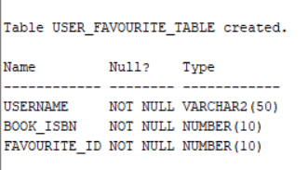

**COMMENTS_TABLE**

CREATE TABLE COMMENTS_TABLE

(

comment_id NUMBER(10, 0) NOT NULL PRIMARY KEY,

ccomment VARCHAR2(255) NOT NULL

);

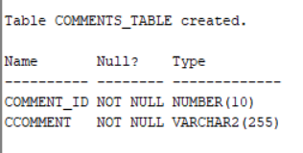

**USER_COMMENT_TABLE**

CREATE TABLE USER_COMMENT_TABLE

(

username VARCHAR2(50) NOT NULL,

book_ISBN NUMBER(10, 0) NOT NULL,

comment_id NUMBER(10, 0) NOT NULL,

PRIMARY KEY(username, book_ISBN, comment_id),

CONSTRAINT FK_USER_COMMENT_TABLEusernamebook_ISBN FOREIGN KEY

(username, book_ISBN) REFERENCES USER_INTERACTION_TABLE (username, book_ISBN) ON DELETE CASCADE,

CONSTRAINT FK_USER_COMMENT_TABLEcomment_id FOREIGN KEY

(comment_id) REFERENCES COMMENTS_TABLE (comment_id) ON DELETE CASCADE

);

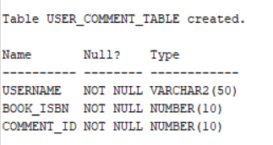

**WISHLIST_TABLE**

CREATE TABLE WISHLIST_TABLE

(

wish_id NUMBER(10, 0) NOT NULL PRIMARY KEY

);

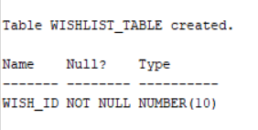

**USER_WISHLIST_TABLE**

CREATE TABLE USER_WISHLIST_TABLE

(

username VARCHAR2(50) NOT NULL,

book_ISBN NUMBER(10, 0) NOT NULL,

wish_id NUMBER(10, 0) NOT NULL,

PRIMARY KEY(username, book_ISBN, wish_id),

CONSTRAINT FK_USER_WISHLIST_TABLEusernamebook_ISBN FOREIGN KEY

(username, book_ISBN) REFERENCES USER_INTERACTION_TABLE (username, book_ISBN) ON DELETE CASCADE,

CONSTRAINT FK_USER_WISHLIST_TABLEwish_id FOREIGN KEY

(wish_id) REFERENCES WISHLIST_TABLE (wish_id) ON DELETE CASCADE

);

